Online Artisan Store
Database Design & Implementation

Introduction

The Online Artisan Store is a database-driven e-commerce system designed to connect artisans with clients who are interested in handmade products. The platform allows artisans to list and manage their products, while clients can browse categories, place orders, make payments, and leave reviews. The system also includes administrative control for managing categories, monitoring orders, and ensuring smooth operations. The main objective of this project is to design and implement a well-structured relational database that ensures data consistency, minimizes redundancy through normalization, and supports real-world business operations such as ordering, payment processing, and delivery tracking.

This report covers the complete database lifecycle including scenario selection, conceptual design, relational schema, normalization, SQL implementation, and advanced database operations such as triggers and stored procedures.

Phase 1 – Scenario Selection & Functional Requirements

Scenario: Online Artisan Store – A platform where artisans list handmade products, clients place orders, and the system tracks payments, deliveries, and reviews.

Functional Requirements:
- Artisans can create and manage their product listings.
- Clients can browse products by categories.
- Clients can place orders, specifying quantities.
- System calculates total order amount automatically.
- Payments can be made online with status tracking.
- Clients can leave reviews and ratings for purchased products.
- Admin can manage categories and monitor orders.
- System supports multiple phone numbers and addresses for users.

Phase 2 – Conceptual Design

Entities, Attributes, Keys, and Special Attributes:

Entity | Attributes (PK/FK/MV/Derived/Composite)
Users | user_id (PK), name (Composite: first_name + last_name), email, password, role, phones (MV), addresses (MV), registration_date
Products | product_id (PK), artisan_id (FK), category_id (FK), product_name, description, price, stock, images (MV), date_added
Categories | category_id (PK), category_name, description
Orders | order_id (PK), client_id (FK), artisan_id (FK), order_date, total_amount (Derived), status
Payments | payment_id (PK), order_id (FK), amount, payment_method, payment_status, payment_date
Order_Details | detail_id (PK), order_id (FK), product_id (FK), quantity, price
Reviews | review_id (PK), order_id (FK), client_id (FK), artisan_id (FK), rating, comments, review_date

Relationships and Cardinalities:
- Users ↔ Products: 1:N (an artisan can list multiple products)
- Categories ↔ Products: 1:N (a category has multiple products)
- Users (client) ↔ Orders: 1:N (client can place many orders)
- Orders ↔ Payments: 1:1
- Orders ↔ Order_Details: 1:N
- Products ↔ Order_Details: 1:N
- Orders ↔ Reviews: 1:N
- Users (client) ↔ Reviews: 1:N
- Users (artisan) ↔ Reviews: 1:N

ER Diagram:

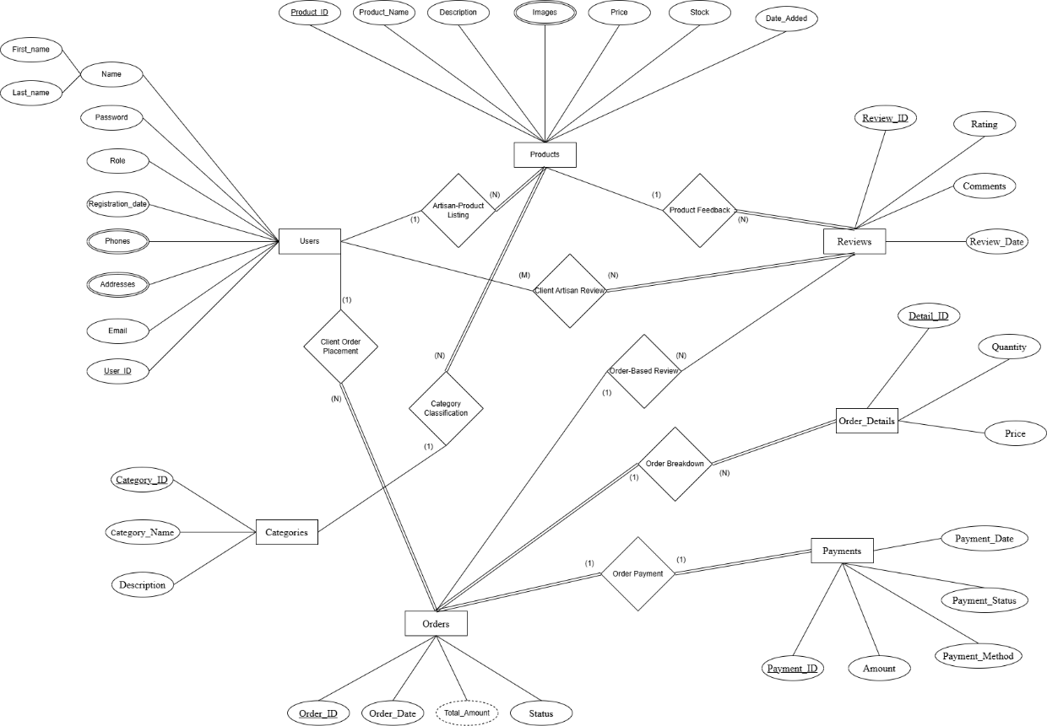

Phase 3 – Logical Design (Relational Schema)

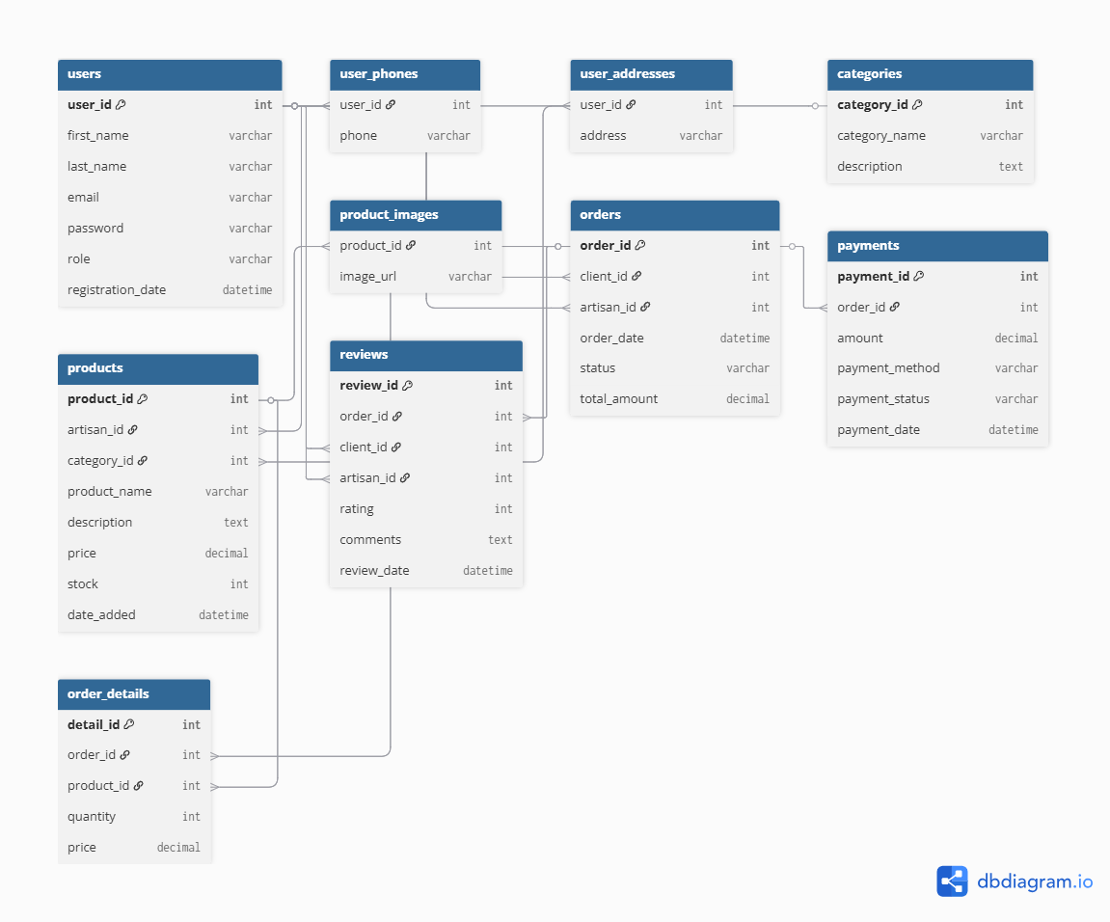

Phase 4 – Normalization

Step 1: 1NF (Atomic Values)
- Ensure all attributes are atomic.
- Multivalued attributes (phones, addresses, images) moved to separate tables (user_phones, user_addresses, product_images).
Step 2: 2NF (No Partial Dependency)
- Every non-key attribute depends on the whole primary key.
- Tables like order_details follow 2NF: quantity and price depend on (order_id, product_id) (or detail_id as PK).
Step 3: 3NF (No Transitive Dependency)
- Non-key attributes depend only on the primary key.
- Example: In orders, total_amount is derived → not stored in 3NF (can be computed).
- All other attributes now directly depend on their table’s PK.
Functional Dependencies (Example):
- users(user_id) → first_name, last_name, email, password, role, registration_date
- products(product_id) → artisan_id, category_id, product_name, description, price, stock, date_added
- order_details(detail_id) → order_id, product_id, quantity, price

Phase 5 – Physical Design & Implementation
  - Write SQL commands:
    - CREATE DATABASE
    - CREATE TABLE (with constraints)
    - Add foreign key relationships

-- =========================================================
-- OPTIONAL: CREATE DATABASE
-- =========================================================
CREATE DATABASE ArtisanDB;
GO
USE ArtisanDB;
GO

-- =========================================================
-- USERS
-- =========================================================
CREATE TABLE Users (
user_id INT IDENTITY(1,1) PRIMARY KEY, -- Internal numeric ID

user_code VARCHAR(10) UNIQUE NULL, -- C001 / A001 stored here

first_name VARCHAR(50) NOT NULL,
last_name VARCHAR(50) NOT NULL,
email VARCHAR(100) UNIQUE NOT NULL,
password VARCHAR(255) NOT NULL,

role VARCHAR(10) NOT NULL, -- 'Client' or 'Artisan'
registration_date DATETIME DEFAULT GETDATE(),

CONSTRAINT chk_role CHECK (role IN ('Client', 'Artisan'))
);GO

-- =========================================================
-- USER PHONES (Composite Key)
-- =========================================================
CREATE TABLE User_Phones (
user_id INT NOT NULL,
phone VARCHAR(20) NOT NULL,
PRIMARY KEY (user_id, phone),
FOREIGN KEY (user_id) REFERENCES Users(user_id)
ON DELETE CASCADE
);
GO

-- =========================================================
-- USER ADDRESSES (Composite Key)
-- =========================================================
CREATE TABLE User_Addresses (
user_id INT NOT NULL,
address VARCHAR(255) NOT NULL,
PRIMARY KEY (user_id, address),
FOREIGN KEY (user_id) REFERENCES Users(user_id)
ON DELETE CASCADE
);
GO

-- =========================================================
-- CATEGORIES
-- =========================================================
CREATE TABLE Categories (
category_id INT IDENTITY(1,1) PRIMARY KEY,
category_name VARCHAR(100) NOT NULL,
description TEXT
);
GO

-- =========================================================
-- PRODUCTS
-- =========================================================
CREATE TABLE Products (
product_id INT IDENTITY(1,1) PRIMARY KEY,
artisan_id INT NOT NULL,
category_id INT NOT NULL,
product_name VARCHAR(100) NOT NULL,
description TEXT,
price DECIMAL(10,2) NOT NULL,
stock INT NOT NULL CHECK (stock >= 0),
date_added DATETIME DEFAULT GETDATE(),

FOREIGN KEY (artisan_id) REFERENCES Users(user_id)
ON DELETE CASCADE,
FOREIGN KEY (category_id) REFERENCES Categories(category_id)
ON DELETE CASCADE
);
GO

-- =========================================================
-- PRODUCT IMAGES (Composite Key)
-- =========================================================
CREATE TABLE Product_Images (
product_id INT NOT NULL,
image_url VARCHAR(255) NOT NULL,
PRIMARY KEY (product_id, image_url),
FOREIGN KEY (product_id) REFERENCES Products(product_id)
ON DELETE CASCADE
);
GO

-- =========================================================
-- ORDERS
-- =========================================================
CREATE TABLE Orders (
order_id INT IDENTITY(1,1) PRIMARY KEY,
client_id INT NOT NULL,
artisan_id INT NOT NULL,
order_date DATETIME DEFAULT GETDATE(),
status VARCHAR(50),
total_amount DECIMAL(10,2), -- Derived but allowed
payment_method VARCHAR(20) NOT NULL DEFAULT 'COD',

FOREIGN KEY (client_id) REFERENCES Users(user_id),
FOREIGN KEY (artisan_id) REFERENCES Users(user_id)
);
GO

-- =========================================================
-- PAYMENTS (1:1 with Orders)
-- =========================================================
CREATE TABLE Payments (
payment_id INT IDENTITY(1,1) PRIMARY KEY,
order_id INT UNIQUE NOT NULL,
amount DECIMAL(10,2) NOT NULL,
payment_method VARCHAR(50) NOT NULL, -- 'COD' or 'Online'
payment_status VARCHAR(50) NOT NULL, -- 'Pending', 'Completed', 'Failed'
payment_date DATETIME DEFAULT GETDATE(),
FOREIGN KEY (order_id) REFERENCES Orders(order_id)
ON DELETE CASCADE
);
GO
CREATE TABLE Online_Payments (
payment_id INT PRIMARY KEY, -- linked to Payments
bank_name VARCHAR(100) NOT NULL,
transaction_id VARCHAR(50) NOT NULL,
FOREIGN KEY (payment_id) REFERENCES Payments(payment_id)
ON DELETE CASCADE
); GO

-- =========================================================
-- ORDER DETAILS
-- =========================================================
CREATE TABLE Order_Details (
detail_id INT IDENTITY(1,1) PRIMARY KEY,
order_id INT NOT NULL,
product_id INT NOT NULL,
quantity INT NOT NULL,
price DECIMAL(10,2) NOT NULL,

FOREIGN KEY (order_id) REFERENCES Orders(order_id)
ON DELETE CASCADE,
FOREIGN KEY (product_id) REFERENCES Products(product_id)
);
GO

-- =========================================================
-- REVIEWS
-- =========================================================
CREATE TABLE Reviews (
review_id INT IDENTITY(1,1) PRIMARY KEY,
order_id INT NOT NULL,
client_id INT NOT NULL,
artisan_id INT NOT NULL,
rating INT CHECK (rating BETWEEN 1 AND 5),
comments TEXT,
review_date DATETIME DEFAULT GETDATE(),

FOREIGN KEY (order_id) REFERENCES Orders(order_id)
ON DELETE CASCADE,
FOREIGN KEY (client_id) REFERENCES Users(user_id),
FOREIGN KEY (artisan_id) REFERENCES Users(user_id)
);
GO

Insert sample data (10–15 records per table) using SQL queries.

- USERS (10 Records)

EXEC sp_AddUserFull
@first_name = 'Abubakar',
@last_name = 'Khan',
@email = 'abubakar.khan@example.com',
@password = 'pass123',
@role = 'Client',
@phone = '03001234501',
@address = 'Lahore, Pakistan';

EXEC sp_AddUserFull
@first_name = 'Fatima',
@last_name = 'Noor',
@email = 'fatima.noor@example.com',
@password = 'pass123',
@role = 'Artisan',
@phone = '03001234502',
@address = 'Karachi, Pakistan';

EXEC sp_AddUserFull
@first_name = 'Hassan',
@last_name = 'Ali',
@email = 'hassan.ali@example.com',
@password = 'pass123',
@role = 'Client',
@phone = '03001234503',
@address = 'Islamabad, Pakistan';

EXEC sp_AddUserFull
@first_name = 'Sara',
@last_name = 'Tariq',
@email = 'sara.tariq@example.com',
@password = 'pass123',
@role = 'Artisan',
@phone = '03001234504',
@address = 'Multan, Pakistan';

EXEC sp_AddUserFull
@first_name = 'Bilal',
@last_name = 'Shah',
@email = 'bilal.shah@example.com',
@password = 'pass123',
@role = 'Client',
@phone = '03001234505',
@address = 'Peshawar, Pakistan';

EXEC sp_AddUserFull
@first_name = 'Ayesha',
@last_name = 'Saeed',
@email = 'ayesha.saeed@example.com',
@password = 'pass123',
@role = 'Artisan',
@phone = '03001234506',
@address = 'Faisalabad, Pakistan';

EXEC sp_AddUserFull
@first_name = 'Zubair',
@last_name = 'Khan',
@email = 'zubair.khan@example.com',
@password = 'pass123',
@role = 'Client',
@phone = '03001234507',
@address = 'Quetta, Pakistan';

EXEC sp_AddUserFull
@first_name = 'Nimra',
@last_name = 'Hassan',
@email = 'nimra.hassan@example.com',
@password = 'pass123',
@role = 'Artisan',
@phone = '03001234508',
@address = 'Sialkot, Pakistan';

EXEC sp_AddUserFull
@first_name = 'Omar',
@last_name = 'Latif',
@email = 'omar.latif@example.com',
@password = 'pass123',
@role = 'Client',
@phone = '03001234509',
@address = 'Hyderabad, Pakistan';

EXEC sp_AddUserFull
@first_name = 'Hina',
@last_name = 'Javed',
@email = 'hina.javed@example.com',
@password = 'pass123',
@role = 'Artisan',
@phone = '03001234510',
@address = 'Sukkur, Pakistan';

- CATEGORIES (10 Records)

INSERT INTO Categories (category_name, description)
VALUES
('Handmade Jewelry', 'Custom jewelry crafted by artisans'),
('Wood Crafts', 'Handmade wood items'),
('Textiles', 'Handwoven clothing and fabric'),
('Ceramics', 'Pottery and ceramic goods'),
('Leather Products', 'Bags, belts, and accessories'),
('Art Paintings', 'Traditional and modern art'),
('Home Decor', 'Decorative handmade items'),
('Toys', 'Handmade wooden toys'),
('Metal Crafts', 'Metal artwork and tools'),
('Organic Products', 'Natural handmade products');

- PRODUCTS (15 Records)

INSERT INTO Products (artisan_id, category_id, product_name, description, price, stock)
VALUES
(1, 1, 'Silver Bracelet', 'Handmade silver bracelet', 1500, 20),
(3, 2, 'Wooden Table', 'Small handcrafted table', 7000, 10),
(5, 3, 'Handwoven Shawl', 'Soft woolen shawl', 2500, 15),
(7, 4, 'Clay Vase', 'Decorative vase', 1200, 30),
(9, 5, 'Leather Wallet', 'Premium handmade wallet', 1800, 40),
(12, 6, 'Landscape Painting', 'Acrylic painting', 9000, 8),
(15, 7, 'Decor Lamp', 'Wooden handcrafted lamp', 3500, 12),
(1, 8, 'Toy Car', 'Wooden toy car', 800, 25),
(3, 9, 'Metal Sword', 'Decorative sword', 5000, 5),
(5, 10, 'Organic Soap Set', 'Herbal soaps', 600, 50),
(7, 1, 'Gold Necklace', 'Handcrafted necklace', 22000, 6),
(9, 2, 'Wood Clock', 'Wall clock', 4500, 10),
(12, 3, 'Cotton Scarf', 'Handmade cotton scarf', 1200, 18),
(15, 4, 'Ceramic Bowl', 'Hand-painted bowl', 900, 22),

(1, 5, 'Leather Belt', 'Genuine leather belt', 1300, 35);

PRODUCT IMAGES (45 Records)

INSERT INTO Product_Images (product_id, image_url) VALUES
(1, 'prod1_img1.jpg'),
(1, 'prod1_img2.jpg'),
(1, 'prod1_img3.jpg'),

(2, 'prod2_img1.jpg'),
(2, 'prod2_img2.jpg'),
(2, 'prod2_img3.jpg'),

(3, 'prod3_img1.jpg'),
(3, 'prod3_img2.jpg'),
(3, 'prod3_img3.jpg'),

(4, 'prod4_img1.jpg'),
(4, 'prod4_img2.jpg'),
(4, 'prod4_img3.jpg'),

(5, 'prod5_img1.jpg'),
(5, 'prod5_img2.jpg'),
(5, 'prod5_img3.jpg'),

(6, 'prod6_img1.jpg'),
(6, 'prod6_img2.jpg'),
(6, 'prod6_img3.jpg'),

(7, 'prod7_img1.jpg'),
(7, 'prod7_img2.jpg'),
(7, 'prod7_img3.jpg'),

(8, 'prod8_img1.jpg'),
(8, 'prod8_img2.jpg'),
(8, 'prod8_img3.jpg'),

(9, 'prod9_img1.jpg'),
(9, 'prod9_img2.jpg'),
(9, 'prod9_img3.jpg'),

(10, 'prod10_img1.jpg'),
(10, 'prod10_img2.jpg'),
(10, 'prod10_img3.jpg'),

(11, 'prod11_img1.jpg'),
(11, 'prod11_img2.jpg'),
(11, 'prod11_img3.jpg'),

(12, 'prod12_img1.jpg'),
(12, 'prod12_img2.jpg'),
(12, 'prod12_img3.jpg'),

(13, 'prod13_img1.jpg'),
(13, 'prod13_img2.jpg'),
(13, 'prod13_img3.jpg'),

(14, 'prod14_img1.jpg'),
(14, 'prod14_img2.jpg'),
(14, 'prod14_img3.jpg'),

(15, 'prod15_img1.jpg'),
(15, 'prod15_img2.jpg'),

(15, 'prod15_img3.jpg');

ORDERS (12 Records)

INSERT INTO Orders (client_id, product_id, quantity)
VALUES
(2, 1, 1),
(4, 2, 3),
(6, 3, 5),
(8, 4, 7),
(10, 5, 9),
(11, 6, 12),
(13, 7, 15),
(14, 8, 1),
(2, 9, 3),
(4, 10, 5),
(6, 11, 7),
(11, 12, 9),
(5, 13, 4),
(7, 14, 2),

(8, 15, 6);

PAYMENTS (10 Records)

INSERT INTO Payments (order_id, amount, payment_method, payment_status)
VALUES
(1, 3000, 'Card', 'Paid'),
(2, 7000, 'Cash', 'Paid'),
(3, 2500, 'Card', 'Paid'),
(5, 1800, 'Card', 'Paid'),
(6, 9000, 'Card', 'Paid'),
(7, 3500, 'Cash', 'Pending'),
(8, 800, 'Card', 'Paid'),
(9, 5000, 'Card', 'Paid'),
(10, 600, 'Cash', 'Paid'),

(12, 4500, 'Card', 'Paid');

REVIEWS (10 Records)

INSERT INTO Reviews (order_id, client_id, artisan_id, rating, comments)
VALUES
(2, 4, 3, 5, 'Excellent craftsmanship!'),
(3, 6, 5, 4, 'Very nice work'),
(5, 10, 9, 5, 'Loved the product!'),
(6, 11, 12, 4, 'Good quality'),
(8, 14, 1, 3, 'Average'),
(9, 2, 3, 5, 'Perfect item'),
(10, 4, 5, 4, 'Highly recommended'),
(12, 11, 9, 5, 'Great experience'),
(7, 13, 15, 4, 'Good but slow delivery'),
(1, 2, 1, 5, 'Amazing product!');

CREATE TABLE Delivery (
delivery_id INT IDENTITY(1,1) PRIMARY KEY,
order_id INT NOT NULL,
delivery_status VARCHAR(50) NOT NULL DEFAULT 'Pending', -- Pending, Out for Delivery, Delivered
delivery_address VARCHAR(255) NOT NULL, -- Must have an address
ship_date DATETIME, -- Automatically filled
delivery_date DATETIME NULL, -- Filled when delivered
tracking_number VARCHAR(40) NOT NULL UNIQUE, -- Unique tracking number
-- Foreign Key
FOREIGN KEY (order_id) REFERENCES Orders(order_id)
ON DELETE CASCADE
);

Phase 6 – CRUD Operations
Write SQL statements for:
  - INSERT, UPDATE, DELETE, SELECT
  - Use conditions: DISTINCT, WHERE, AND/OR, IN, BETWEEN

Phase 7 – Advanced SQL
  - Aggregate Functions (SUM, AVG, MAX, MIN, COUNT) with GROUP BY, HAVING, ORDER BY
  - Joins: Write INNER JOIN, LEFT JOIN queries
  - Subqueries: Use in WHERE or HAVING clause

- Update Payment Status When Delivery Is Completed
CREATE TRIGGER trg_CompletePaymentOnDelivery
ON Delivery
AFTER UPDATE
AS
BEGIN
SET NOCOUNT ON;

UPDATE P
SET payment_status = 'Completed'
FROM Payments P
INNER JOIN inserted I ON P.order_id = I.order_id
WHERE I.delivery_status = 'Delivered';
END;
GO

- Place Order with Price & Total Amount

IF OBJECT_ID('PlaceOrder', 'P') IS NOT NULL
DROP PROCEDURE PlaceOrder;
GO
CREATE PROCEDURE PlaceOrder
@ClientID INT,
@ProductID INT,
@Quantity INT,
@PaymentMethod VARCHAR(20), -- 'COD' or 'Online'
@BankName VARCHAR(100) = NULL, -- optional for Online
@TransactionID VARCHAR(50) = NULL -- optional for Online
AS
BEGIN
SET NOCOUNT ON;

DECLARE @Price DECIMAL(10,2);
DECLARE @OrderID INT;
DECLARE @ProductName VARCHAR(100);
DECLARE @TotalAmount DECIMAL(10,2);

-- Fetch product info
SELECT @Price = price, @ProductName = product_name
FROM Products
WHERE product_id = @ProductID;

IF @Price IS NULL
BEGIN
PRINT 'Product does not exist.';
RETURN;
END

DECLARE @CurrentStock INT;
SELECT @CurrentStock = stock FROM Products WHERE product_id = @ProductID;

IF @Quantity > @CurrentStock OR @CurrentStock <= 0
BEGIN
PRINT ' Not enough stock.';
RETURN;
END

SET @TotalAmount = @Price * @Quantity;

-- Insert order
INSERT INTO Orders (client_id, product_id, quantity, payment_method)
VALUES (@ClientID, @ProductID, @Quantity, @PaymentMethod);

SET @OrderID = SCOPE_IDENTITY();

-- Insert payment
INSERT INTO Payments (order_id, amount, payment_method, payment_status)
VALUES (
@OrderID,
@TotalAmount,
@PaymentMethod,
CASE WHEN @PaymentMethod = 'COD' THEN 'Completed' ELSE 'Pending' END
);

DECLARE @PaymentID INT = SCOPE_IDENTITY();

-- Online payment details
IF @PaymentMethod = 'Online'
BEGIN
IF @BankName IS NULL OR @TransactionID IS NULL
BEGIN
RAISERROR('Bank Name and Transaction ID are required for online payment.',16,1);
ROLLBACK TRANSACTION;
RETURN;
END

INSERT INTO Online_Payments (payment_id, bank_name, transaction_id)
VALUES (@PaymentID, @BankName, @TransactionID);
END

-- Reduce stock
UPDATE Products
SET stock = stock - @Quantity
WHERE product_id = @ProductID;

-- Print receipt
PRINT '==========================================';
PRINT 'ORDER RECEIPT';
PRINT 'Order ID: ' + CAST(@OrderID AS VARCHAR);
PRINT 'Client ID: ' + CAST(@ClientID AS VARCHAR);
PRINT 'Product: ' + @ProductName;
PRINT 'Quantity: ' + CAST(@Quantity AS VARCHAR);
PRINT 'Price per Unit: $' + CAST(@Price AS VARCHAR);
PRINT 'Total Amount: $' + CAST(@TotalAmount AS VARCHAR);
PRINT 'Payment Method: ' + @PaymentMethod;

IF @PaymentMethod = 'Online'
BEGIN
PRINT 'Bank: ' + @BankName;
PRINT 'Transaction ID: ' + @TransactionID;
END

DECLARE @RemainingStock INT;
SELECT @RemainingStock = stock FROM Products WHERE product_id = @ProductID;
PRINT 'Remaining Stock: ' + CAST(@RemainingStock AS VARCHAR);
PRINT '==========================================';
END;
GO

EXEC PlaceOrder
@ClientID = 3,
@ProductID = 9,
@Quantity = 3,
@PaymentMethod = 'Online',
@BankName = 'HBL',
@TransactionID = 'TXN12345';

EXEC PlaceOrder
@ClientID = 3,
@ProductID = 9,
@Quantity = 3,
@PaymentMethod = 'COD';

- Update ship and delivery date
CREATE OR ALTER TRIGGER trg_UpdateDeliveryTimestamps
ON Delivery
AFTER UPDATE
AS
BEGIN
SET NOCOUNT ON;

-- When delivery_status changes, update timestamps
UPDATE D
SET
ship_date =
CASE
WHEN I.delivery_status = 'Out for Delivery'
AND D.ship_date IS NULL
THEN GETDATE()
ELSE D.ship_date
END,

delivery_date =
CASE
WHEN I.delivery_status = 'Delivered'
AND D.delivery_date IS NULL
THEN GETDATE()
ELSE D.delivery_date
END
FROM Delivery D
INNER JOIN inserted I ON D.delivery_id = I.delivery_id;
END;
GO

- Updating data automatically in OrdersDetail Table
IF OBJECT_ID('trg_UpdateOrderDetailsStatus_OnDelivery', 'TR') IS NOT NULL
DROP TRIGGER trg_UpdateOrderDetailsStatus_OnDelivery;
GO

CREATE TRIGGER trg_UpdateOrderDetailsStatus_OnDelivery
ON Delivery
AFTER UPDATE
AS
BEGIN
SET NOCOUNT ON;

-- Update Order_Details.status based on updated delivery_status
UPDATE OD
SET OD.status = CASE
WHEN I.delivery_status = 'Delivered' THEN 'Completed'
WHEN I.delivery_status = 'Out for Delivery' THEN 'Out for Delivery'
ELSE OD.status
END
FROM Order_Details OD
INNER JOIN inserted I ON OD.order_id = I.order_id;
END;
GO

CREATE TRIGGER trg_GenerateUserCode
ON Users
AFTER INSERT
AS
BEGIN
SET NOCOUNT ON;

UPDATE U
SET user_code =
CASE
WHEN I.role = 'Client' THEN
'C' + RIGHT('000' + CAST(I.user_id AS VARCHAR(3)), 3)
WHEN I.role = 'Artisan' THEN
'A' + RIGHT('000' + CAST(I.user_id AS VARCHAR(3)), 3)
END
FROM Users U
INNER JOIN inserted I ON U.user_id = I.user_id;
END;
GO

- Adding Users
CREATE PROCEDURE sp_AddUserFull
@first_name VARCHAR(50),
@last_name VARCHAR(50),
@email VARCHAR(100),
@password VARCHAR(255),
@role VARCHAR(10), -- 'Client' or 'Artisan'
@phone VARCHAR(20), -- One phone number
@address VARCHAR(255) -- One address
AS
BEGIN
SET NOCOUNT ON;

DECLARE @prefix CHAR(1);
DECLARE @next_number INT;
DECLARE @user_code VARCHAR(10);
DECLARE @new_user_id INT;

-- 1️⃣ Determine prefix based on role
IF @role = 'Client'
SET @prefix = 'C';
ELSE
SET @prefix = 'A';

-- 2️⃣ Get next number for this role
SELECT @next_number = ISNULL(
MAX(CAST(SUBSTRING(user_code, 2, LEN(user_code)-1) AS INT)), 0) + 1
FROM Users
WHERE user_code LIKE @prefix + '%';

-- 3️⃣ Build user_code like C001 or A001
SET @user_code = @prefix + RIGHT('000' + CAST(@next_number AS VARCHAR(3)), 3);

-- 4️⃣ Insert into Users table
INSERT INTO Users (user_code, first_name, last_name, email, password, role)
VALUES (@user_code, @first_name, @last_name, @email, @password, @role);

SET @new_user_id = SCOPE_IDENTITY();

-- 5️⃣ Insert into User_Phones
INSERT INTO User_Phones (user_id, phone)
VALUES (@new_user_id, @phone);

-- 6️⃣ Insert into User_Addresses
INSERT INTO User_Addresses (user_id, address)
VALUES (@new_user_id, @address);

-- 7️⃣ Return inserted info
SELECT
@new_user_id AS user_id,
@user_code AS user_code,
@first_name + ' ' + @last_name AS full_name,
@role AS role,
@phone AS phone,
@address AS address;
END;
GO

- CREATE AUTO DELIVERY
CREATE TRIGGER trg_AutoCreateDelivery
ON Orders
AFTER INSERT
AS
BEGIN
SET NOCOUNT ON;

INSERT INTO Delivery (order_id, delivery_status, delivery_address, ship_date, delivery_date, tracking_number)
SELECT
I.order_id,
'Pending',
UA.address,
NULL,
NULL,
'TRK' + RIGHT('000000' + CAST(I.order_id AS VARCHAR(6)), 6)
FROM inserted I
INNER JOIN User_Addresses UA ON UA.user_id = I.client_id
WHERE UA.address IS NOT NULL;
END;
GO

- FILL ORDER DETAILS
CREATE TRIGGER trg_FillOrderDetails
ON Orders
AFTER INSERT
AS
BEGIN
SET NOCOUNT ON;

INSERT INTO Order_Details (order_id, artisan_id, price, status, order_date)
SELECT
I.order_id,
P.artisan_id,
P.price,
'Pending',
GETDATE()
FROM inserted I
INNER JOIN Products P ON I.product_id = P.product_id;
END;
GO

- Trigger to Prevent Skipping Delivery Status and Ensure Valid Delivery Progression
CREATE TRIGGER trg_CheckDeliveryStatusFlow
ON Delivery
AFTER UPDATE
AS
BEGIN
SET NOCOUNT ON;

-- Prevent skipping from Pending directly to Delivered
IF EXISTS (
SELECT 1
FROM inserted I
INNER JOIN deleted D ON I.delivery_id = D.delivery_id
WHERE D.delivery_status = 'Pending'
AND I.delivery_status = 'Delivered'
)
BEGIN
RAISERROR('Cannot change delivery status directly from Pending to Delivered. Must go through Out for Delivery.', 16, 1);
ROLLBACK TRANSACTION;
RETURN;
END
END;
GO

